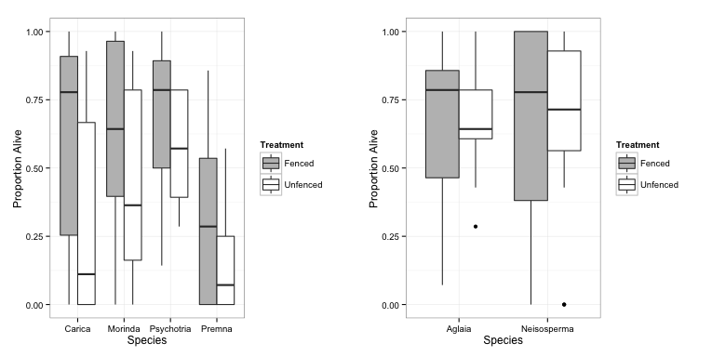

Figure 1. A higher proportion of seedlings remained alive in fenced versus unfenced plots for four out of six forest species, as displayed in the left panel. For *Carica papaya*, *Morinda citrifolia*, *Psychotria mariana*, and *Premna obtusifolia*, the best fit model for proportion alive included treatment. For *Aglaia mariannensis* and *Neisosperma oppositifolia* seedlings, island rather than treatment played a stronger role in determining the best fit model explaining proportion of seedlings alive.

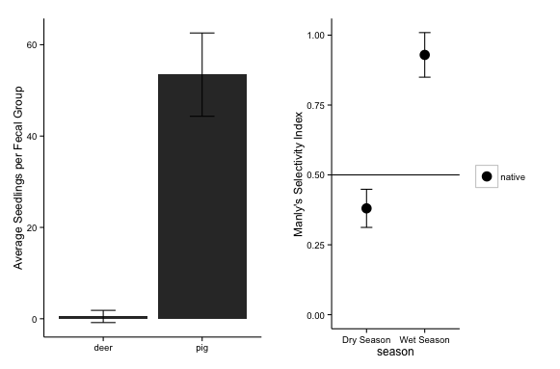

Figure 2. The average number of seedlings that germinated per fecal group was larger from pigs (n= 31 fecal groups with an average of 53.45 ± 9.12 seedlings per fecal group) than from deer (n=20 fecal groups with an average of 0.5 ± 1.34 seedlings per fecal group)(left panel). Manly’s Selectivity Index was calculated for pig fecal groups collected during dry season, and for pig fecal groups collected during wet season. While there was a small difference in selectivity during dry season, showing selection for exotic species, there was a strong selection for native species during rainy season. Values for this index for exotic species are equivalent to the value for native species subtracted from 1.

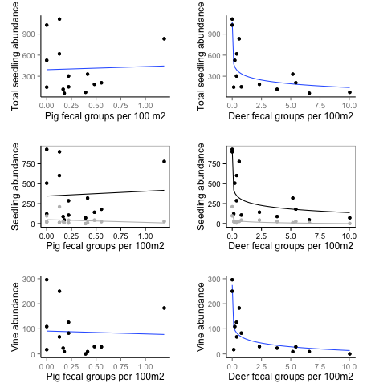

Figure 3. In the left-hand column, regression analysis between abundance of pig fecal groups (relative index for population abundance) showed no relationship with total seedling abundance, exotic nor native seedling abundance (middle row, with black line for native and gray line for exotic), nor vine abundance per survey site in Guam. In the right hand column, abundance of deer fecal groups (relative index for population abundance) show strong negative loglinear relationships to total seedling abundance (R2 = 0.710), native seedling abundance (R2 = 0.647), exotic seedling abundance (R2 = 0.696), and to vine abundance (R2 = 0.751).